Supplementary Figures:

This supplementary file contains Figure S1-S11

Figure S1. An example showing triggered earthquakes. a) Raw waveform recorded by station OMRZ.EHZ. b) Filtered waveform using a 10-30 Hz band-pass filter. c) Spectrogram.

Figure S2. An example showing one mislocated earthquake (a) and its nearby reliable event (b). The wrongly associated event (a) utilized part of the phase picks (red vertical bars) of an event from the aftershock region (blue filled star, with origin time and phase picks marked with blue vertical dashed line and blue vertical bars) and resolved a badly constrained location (red filled star). Inserted maps show the distribution of stations used for event association.

Figure S3. Cumulative frequency-magnitude distribution for the GeoNet Catalog (1,466 earthquakes, red squares), detection catalog of 12MAD (7,513 events, blue), and detection catalog of 9MAD (12,291 events, black). Magnitude of completeness (Mc, marked with cross symbol) and b value for each catalog are labeled.

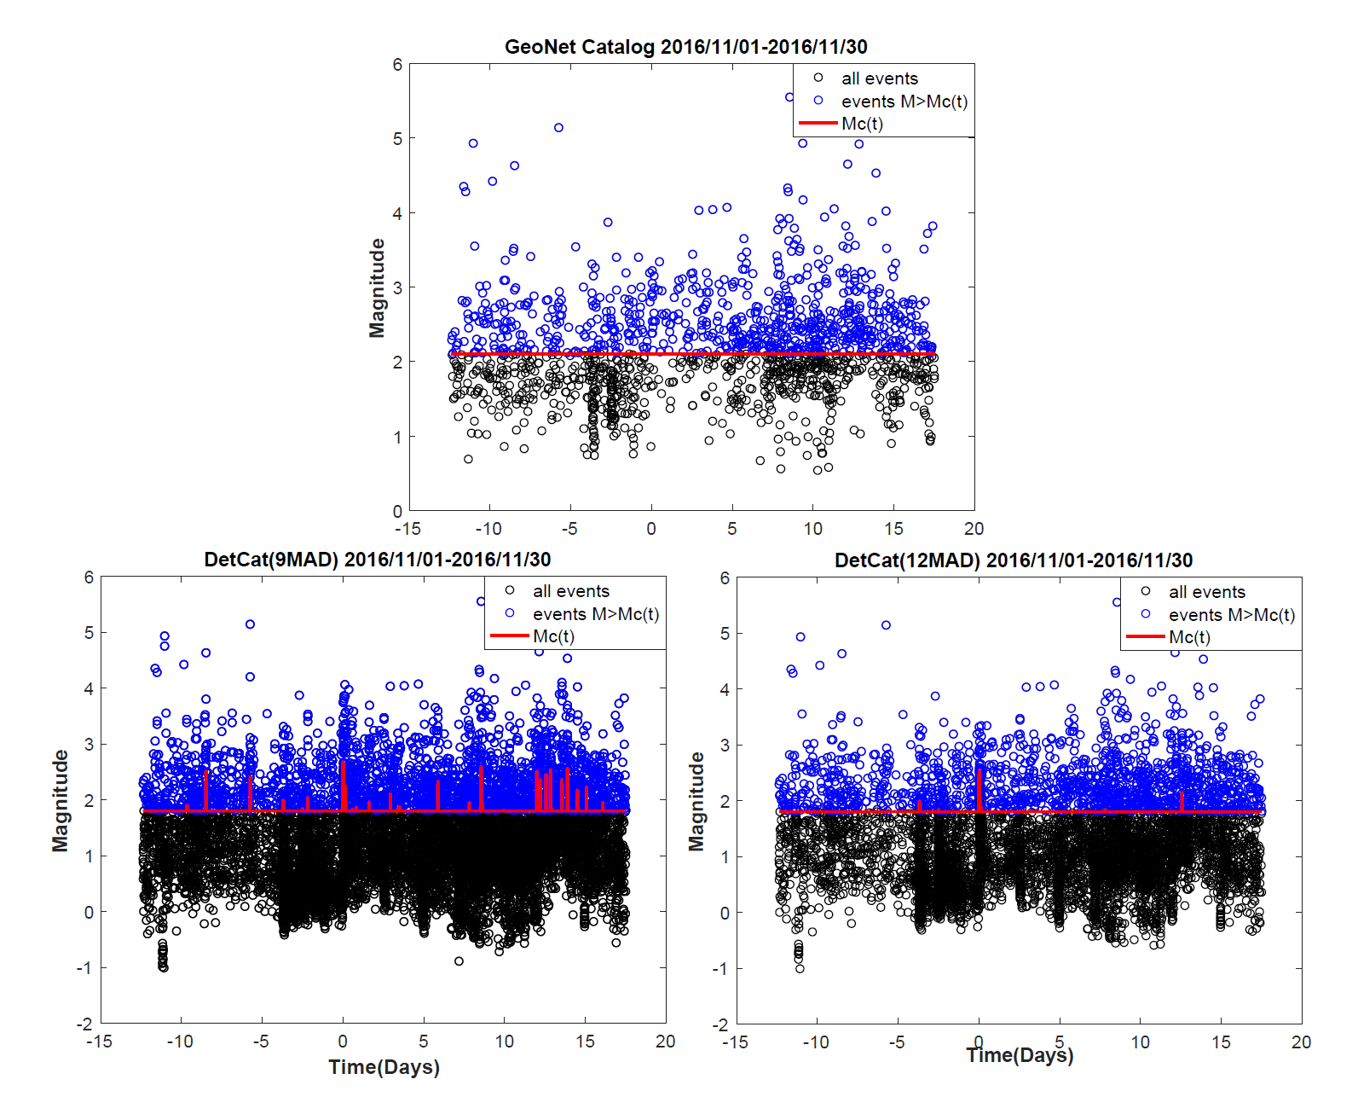

Figure S4. Time-dependent Mc(t) (red curve) for both template (top) and detected catalog (bottom left: 9MAD; bottom right: 12MAD). Events with magnitude M>Mc(t) are shown with blue circles, which are further used for beta statistics.

Figure S5. Beta map for the template and detected catalog (12MAD), with time-depended Mc(t) applied. a) and b): short-term change using 1day after the mainshock as the “triggered window”. c) and d): long-term change using mainshock to the end of Nov (~17.5 days) as the “triggered window”.

Figure S6. Comparison between the daily seismicity rate for the detection (12MAD) and calculated dynamic stress (*Holden’s Model*), similar to Figure 8. a) and c) show the daily seismicity rate in short “triggered window” at shallow depth (0-10km) range, and long “triggered window” within depth range of 10-20km. b) and d) indicate the defined dynamic stress “susceptibility”.

Figure S7. Comparison between the daily seismicity rate for the detection (9MAD) and calculated dynamic stress, similar to Figure 8. Dynamic stress changes and dynamic stress susceptibility using the Kaikōuraearthquake source model of Wang et al. [2018], which includes large moment release (~45% of the total) from the Hikurangi subduction interface.

Figure S8. Comparison between the daily seismicity rate for the detection (12MAD) and calculated dynamic stress. Source model of Wang et al. [2018] is applied, similar to Figure S7.

Figure S9. Left panel showing events listed in the detection catalog in the first 1200s after the mainshock. Red and blue filled circles correspond to newly detected and template event. Right panel plots out the waveform for selected station in the left panel. Lowpass filtered waveform for station NZ.OPRZ is plotting on top to demonstrate the seismic wave train of the mainshock. Red and blue dashed lines indicate template and newly detected events.

Figure S10. SNR synthetic test. a)-c): three component continuous waveform of the nearest station NZ.TWVZ (11.4km). A ML2.1 catalog event was added evenly every 300s with decreasing amplitudes. d)-f) CC function of above three components. g) stacked CC function for above 3 traces. Detections using 9MAD as the cut-off threshold (horizontal dashed line) is shown with blue filled circles. h) stacked CC function for all 37 traces for this template with SNR above 5 (see main text for choosing trace in template matching).

Figure S11. A comparison between the GeoNet earthquakes within the study region in North Island. Blue circles were catalog events used in Peng et al. [2018], while red are those events in the updated GeoNet catalog last accessed Sep 2020.